**Interfacing Push button to 8051 using Interrupts**

**Lab #04**



Spring 2022

CSE-307L Microprocessor Based system Design

Submitted by: **Ashfaq Ahmad**

Registration No: **19PWCSE1795**

Class Section: **B**

“On my honor, as student of University of Engineering and Technology, I have neither given nor received unauthorized assistance on this academic work.”

Student Signature: ______________

Submitted to:

**Dr: Aber Irfan sab**

**July** 25, 2022

**Department of Computer Systems Engineering**

**University of Engineering and Technology, Peshawar**

**Task 01:** Write a program for a microcontroller which keep even LEDS on and odd LEDS off but when any external interrupt occur it will toggle all LEDs for 20msec.

**Source Code:**

#include <reg51.h> //oscillator clock frequency= 12MHz, time period=1us

#include <stdio.h>

sbit led1=P1^0;

sbit led2=P1^1;

sbit led3=P1^2;

sbit led4=P1^3;

//we need 20ms delay in ISR

//20ms/1us=20000 and 65535-20000.

//Note: timer register value increase in each micro-second if clcok F=12Mhz.

//so 20000 wil take 20000 us and 20000us=20ms.

int i;

void delay()

{

TMOD=0x01; //timer 0 of mode 16 bit

for(i = 0; i<100; i++)

{

TH0 = 0xB1; //FFFF-4C13=B1DF=45535= 20 msec

TL0 = 0xDF;

TR0=1;

while(TF0 == 0); //polling

TF0 = 0;

TR0 = 0;

}

}

void ISR() interrupt 0

{

led1=~led1;

led2=~led2;

led3=~led3;

led4=~led4;

delay();

}

void main()

{

IE=0x81; //enable external interrupt 0

IT0=1; //edge trigger. i,e at low-to-high edge of EXT0 it go to ISR and wait there for 20ms.

while(1)

{

led1=1;

led2=0;

led3=1;

led4=0;

}

}

**Output: (interrupt not occurred):**

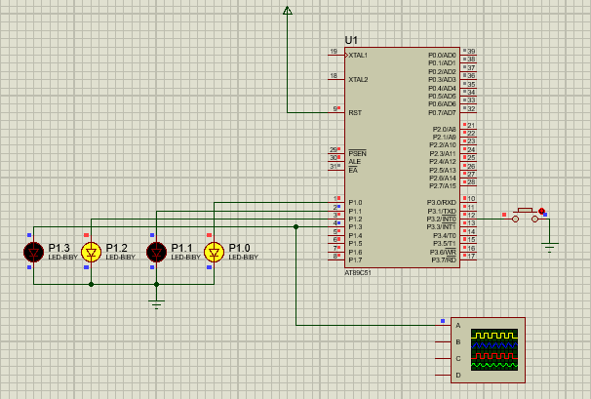

**Interrupt Occurred:**

